Assignment- 4
Name -SATISH KUMAR
MCA 2nd Semester
Roll- 244CA046

1. List all students who have taken exactly 60 total credits

SELECT name
FROM student
WHERE tot_cred = 60;
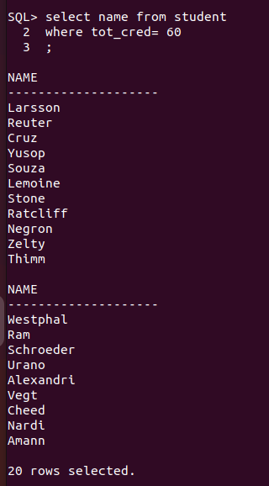

2. Find the names of all courses offered by the "Electrical Engineering" department1
SELECT title
FROM course
WHERE dept_name = 'Elec. Eng.';
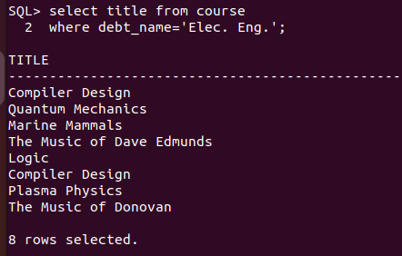

3. Retrieve the names of all instructors who earn less than ₹40,000
SELECT name
FROM instructor
WHERE salary < 40000;
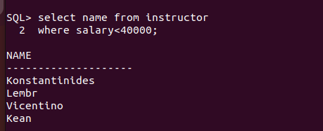

4. List all classrooms located in the "Main" building
SELECT room_number
FROM classroom
WHERE building = 'Main';
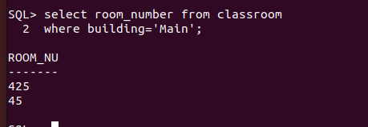

5. Find the total number of courses offered in the "Fall" semester
SELECT COUNT(Distinct course_id)
FROM section
WHERE semester = 'Fall';
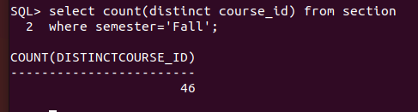

6. List all students who have taken exactly 90 total credits

SELECT name
FROM student
WHERE tot_cred = 90;
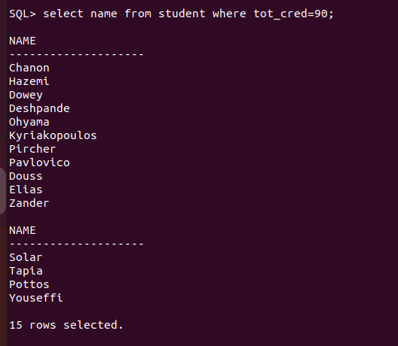

7. Find the names of all courses offered by the "Mechanical Engineering" department
SELECT title
FROM course
WHERE dept_name = 'Mechanical Engineering';
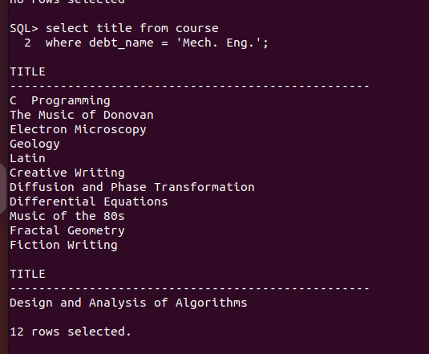
8. Retrieve the names of all instructors who earn exactly ₹75,000
SELECT name
FROM instructor
WHERE salary = 35023.18;

9. List all classrooms located in the "Power" building
SELECT room_number, capacity
FROM classroom
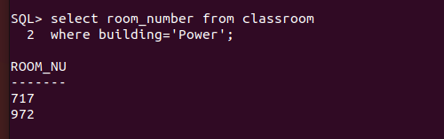
WHERE building = 'Power';

10. Find the total number of courses offered in the "Spring" semester
SELECT COUNT(*)
FROM section
WHERE semester = 'Spring';

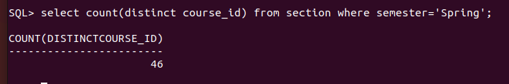

11. List all students who have taken courses with a grade of "B" in the "Spring" semester of 2023
SELECT *
FROM student s
JOIN takes t ON s.id = t.id
WHERE t.grade = 'B ' AND t.year = 2003 AND t.semester = 'Spring';

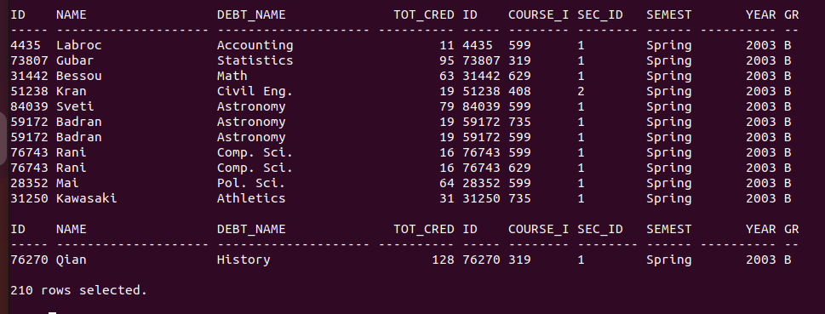

12. Retrieve the names of instructors who have taught in the "Summer" semester of 2022

select i.name from instructor i join teaches t on i.id=t.id
2 where t.semester='Spring' and t.year=2007;

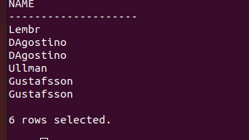

13. Find the average number of credits offered by each department
select debt_name ,avg(credits) as avg_credit
2 from course
3 group by debt_name;
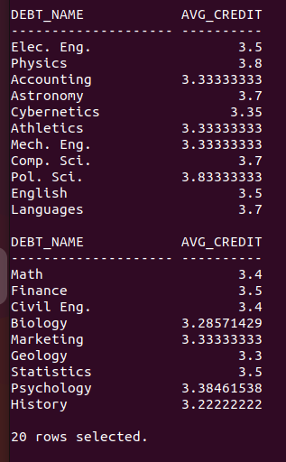

14. List all courses that have exactly 1 creditSELECT title
FROM course
WHERE credits = 3;
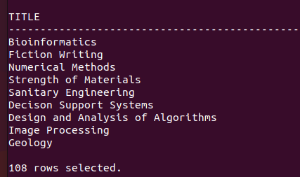

15. Retrieve the names of students who have taken courses in the "Painter" building
SELECT DISTINCT s.name
2 FROM student s
3 JOIN takes t ON s.ID = t.ID
4 JOIN section sec ON t.course_id=sec.course_id
5 WHERE sec.building = 'Power';

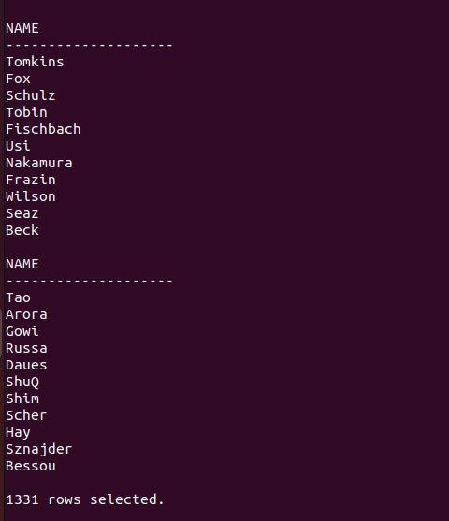

16. Find the total number of students enrolled in each course
SELECT course_id, COUNT(DISTINCT ID) AS total_students
FROM takes
GROUP BY course_id;
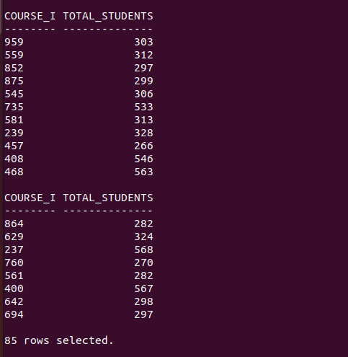

17. List all sections that are held in rooms with a capacity of more than 100
SELECT course_id, sec_id, semester, year ,building,year
FROM section
WHERE (building,room_number) IN (
SELECT building, room_number
FROM classroomWHERE capacity > 100 );
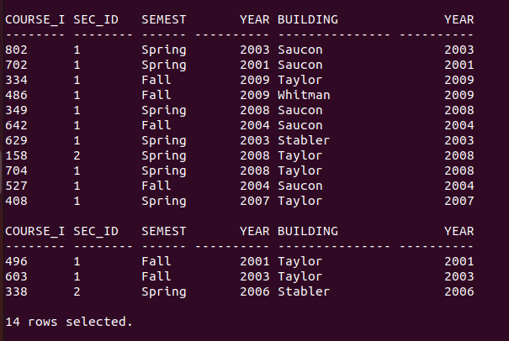

18. Retrieve the names of students who have taken courses with the highest number of credits in their department
SELECT distinct s.name
FROM student s
JOIN takes t ON s.ID = t.ID
JOIN course c ON t.course_id = c.course_id
WHERE c.credits = (
SELECT MAX(credits)
FROM course
WHERE debt_name = c.debt_name
);


19. Find the departments with the highest total budget
SELECT dept_name, MAX(budget) AS highest_budget
FROM department
GROUP BY dept_name;
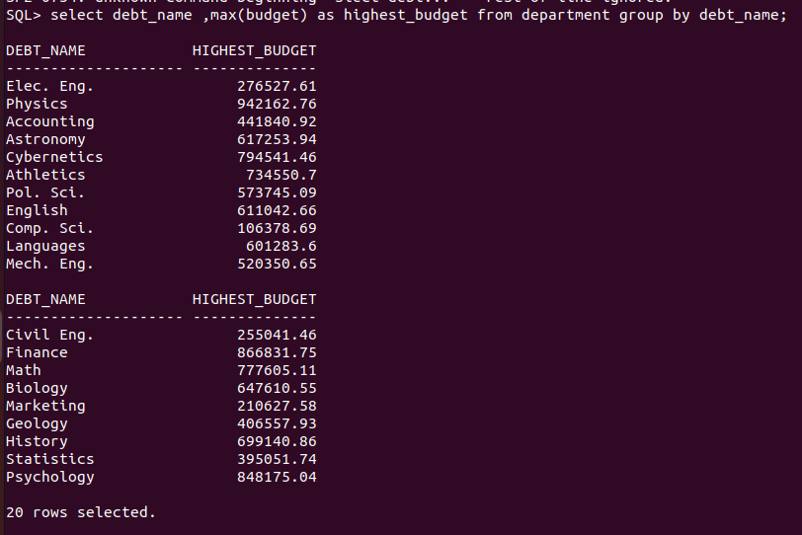
20. List all courses that have been taught by more than 1 instructors
SELECT course_id
FROM teaches
GROUP BY course_id
HAVING COUNT(DISTINCT id) >1;


21. List all students who have taken courses with a grade of "C" in the "Winter" semester of 2023
select * from student s join takes t on s.id=t.id
where grade ='C ' and t.semester='Fall' and t.year=2007;
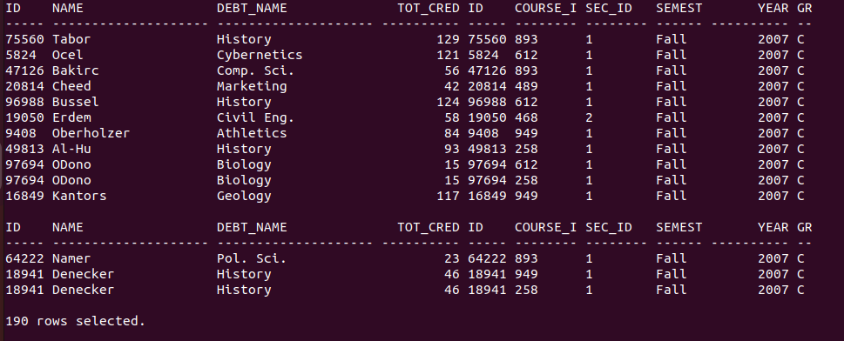

22. Retrieve the names of instructors who have taught in the "Fall" semester of 2021
select distinct i.name from instructor i join teaches t on i.id=t.id
where semester='Fall' and year=2006;

23. Find the average number of sections taught per course
SELECT distinct course_id, AVG(section_count) AS avg_sections
FROM (
SELECT course_id, COUNT(*) AS section_count
FROM section
GROUP BY course_id
)
GROUP BY course_id;
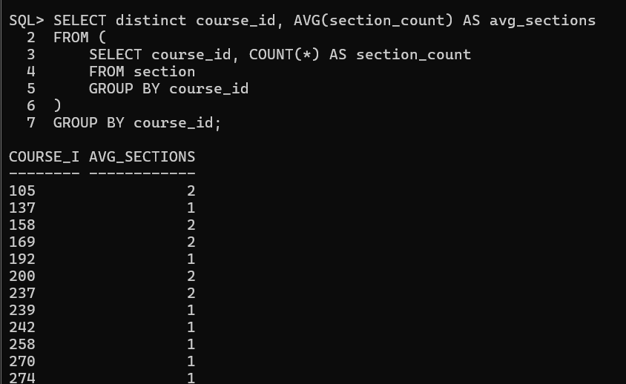

24. List all courses that have exactly 2 credits
SELECT course_name
FROM course
WHERE credits = 3;


25. Retrieve the names of students who have taken courses in the "Taylor" building
select distinct s.name from student s
2 join takes t on s.id = t.id
3 join section se on t.course_id=se.course_id
4 WHERE se.building = 'Taylor';
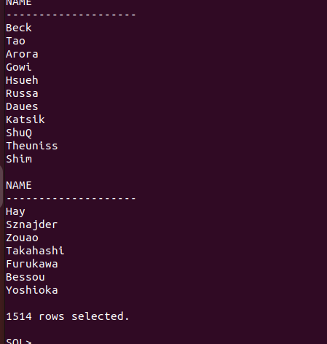

26. Find the total number of courses taught by each instructor
SELECT id, COUNT(DISTINCT course_id) AS total_courses
FROM teaches
GROUP BY id;
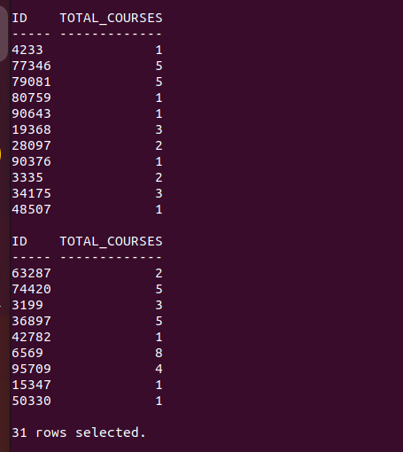

27. List all sections that are held in rooms with a capacity of > 75
SELECT course_id, sec_id, semester, year
FROM section
WHERE (building, room_number) IN (
SELECT building, room_number
FROM classroom
WHERE capacity = 75
);
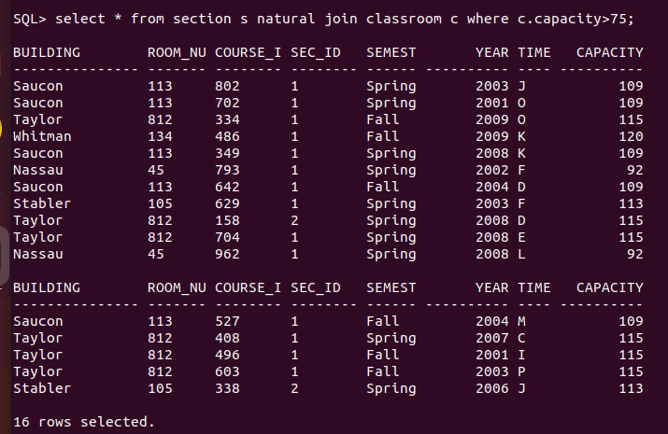

28. Retrieve the names of students who have taken courses with the lowest number of credits in their department

select distinct name from student s
natural join takes t
natural join course c
where credits=(
select min(credits) from course

where debt_name=debt_name);

